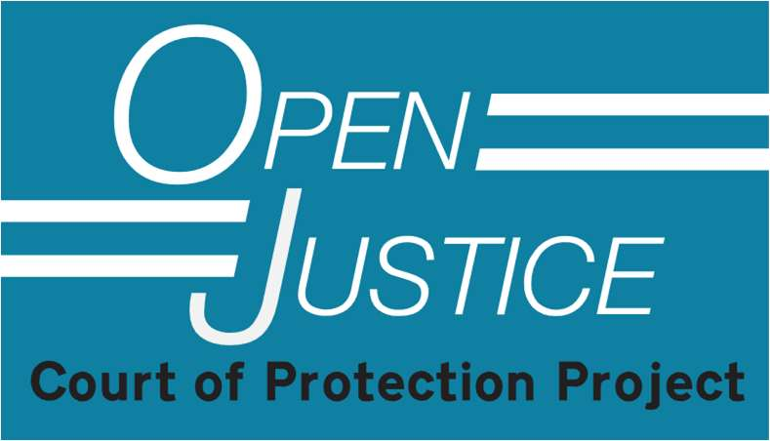

Author Guidance for Blog Posts about COP hearings
We are delighted that you are interested in writing or contributing to a blog post for the Open Justice Court of Protection Project.
We have produced this guidance to help bloggers ensure that they produce material that conforms with to the legal requirements of the Court of Protection transparency framework and with our own policy and style.
We prefer you to get in touch with us before submitting a blog post so that we can provide the support that is likely to mean your blog post is publishable. For example, we can attend a hearing (remotely) with you and discuss what happened. We can help you complete a “Hearing Observer Feedback Form” – which is usually the best way of starting a blog post. We can help with structure and draft revisions. We have a WhatsApp Group for observers which gives you the opportunity to observe with other people.
If you have any questions, or are unsure about any of the guidance below, please feel free to get in touch with us by emailing us at openjustice@yahoo.com
We publish two different types of blog post: “explainers” and accounts of hearings. This guidance is for members of the public who have observed hearings and want to write blog posts about them.
The best way to start is:
- Attend a hearing with a member of the core team, or another experienced observer, so we can support you.
- Complete a Hearing Observation Feedback Form, and send it to us saying that you’d like to write a blog about the hearing, perhaps adding what it is about the hearing that you found particularly interesting and would like to focus on.
- Read some of the published blogs before you start, to get a sense of the different ways in which people have approached blog-writing.
- Submit a draft and the Transparency Order and we will work with you to develop the blog to publishable form.
.
1. Word limits
We are fairly relaxed about word limits. Blog posts are normally 500 -2000 words. Please talk to us first if you want to write something in excess of 2000 words. If you have something to say about a hearing you observed but it’s just a paragraph or a few sentences, send it in as a ‘comment’ and (if we can) we’ll incorporate it into a ‘collective’ blog expressing the views of a range of different observers.
2. Transparency Orders
We ask that you submit the Transparency Order (the court injunction concerning reporting restrictions) at the same as submitting your Hearing Observation Feedback Form and certainly by the time you submit your blog post. This enables us to check that (so far as we can tell) nothing in what you have written contravenes the injunction. It is your responsibility in the first instance to ensure that this is so. We do recognise that the court does not always send out Transparency Orders and can help you with this if you’ve had difficulty obtaining it.
3. Editorial input
We publish blog posts only if they comply with the Open Justice Court of Protection Policy Document which you can download from our website (https://openjusticecourtofprotection.org/about/) and will suggest changes or deletions as appropriate. We will also work with authors to ensure that the blog post is as accurate and engaging as possible.
4. Style Guide
We would like you to write about your experience of observing the hearing, rather than simply give a ‘factual’ account of what happened in the hearing itself.
We’d like you to cover your experience of gaining access to the hearing. Did you go in person or attend remotely and was it straightforward or not? Sometimes that’s all a blog is about (e.g. My first in-person observation at the Royal Courts of Justice)
We’d like to know something about what you bring to the hearing you observed - your personal or family experience with decision-making and capacity, your professional involvements. And we’d like to be told something about what you take away from the hearing – what surprised you, engaged you, enraged you or bemused you.
Was the decision about some issue you have experience with – if so, say so and use your personal experience to reflect on what you observed. Did you feel that the way the case was handled was appropriate?
Be sure to provide evidence for your assessments. If you think something was done well (or badly), don’t just say that: describe what it was about the way it was done that was good (or bad), and why. If you attribute emotions to people (e.g. saying someone was angry, or upset or irritated), always say what it was about what the person said, the way they said it, or how they behaved which lead to you believe that’s what they were feeling.
Blog posts are not academic articles or legal reports, so please write in a clear, direct and accessible style. It will help if you have a look at some of the blog posts that have already been published.
You do not have to cover everything that happened in a hearing – you can focus on just one aspect of it. For example, see this blog post which singles out just one thing that happened in a hearing, like this blog: Addressing the Oral Judgment to the Person it Most Concerns
You can be critical of what you observe, as in these blog: Marking one’s own homework: A “fair-minded observer’s” view of a recusal refusal and Anonymising P and his family in the courtroom: An unnecessary and unhelpful precaution
You can write about just one hearing, or you can combine several observations – either in the same case, or across cases - in a single post.
We encourage you to reflect on what you learn from the hearing – “with both your
head and your heart”, as Clare Fuller does here: Bearing Witness: Anorexia Nervosa and NG Feeding
You can incorporate images from social media material into your blog posts if they’re relevant and don’t breach anyone’s copyright as in this blog post: A first experience of observing in the Court of Protection
If a group of people are all observing the same hearing, we sometimes suggest a group blog post (which we will coordinate). You can see examples of these here: Tampering with equipment or failings in care? A fact-finding hearing (Part 1) ; Hunger Striking for his Identity: Autonomy, Capacity, and Justice, Seven Perspectives on a Court of Protection hearing and Family witnesses in court: Four reflections on Re AH (A Rehearing)
5. Pronouns
Use the pronoun a person (so far as you know) would choose for themselves. Please do NOT use “they/them/their” (in place of she/her or he/him) in an attempt to introduce an extra layer of anonymity. Only use “they/them/their” if you know that’s what the person chooses for themselves. Please do not switch people’s sex/gender in an attempt to further anonymise blogs. This is unnecessary and could be unacceptable to the people you are writing about. If someone is identified as trans in the course of a hearing, please report that fact.
6. Quotations
Use direct quotations where possible. This depends on getting what’s said written down
accurately during the hearing. Your quotations are unlikely to be word perfect but should
be as close as you can get them. This is especially useful for vivid turns of phrase or for
exchanges that are unusual or compelling. Here are some examples from blogs we have
already published.
(a) Short direct quotation incorporated into the text:
He is unfailingly respectful of others, being careful to state that the staff in his care home were “courteous and hardworking” and that his eagerness to leave is “no reflection on them”. A rare moment of agitation came in response to the suggestion that he might have begun to integrate into care home life, perhaps going for a stroll with another resident. This, he says, is “absolute nonsense...it is a factual lie that I have a connection with any individual” (July hearing). He distinguishes himself from the other residents with whom, he explains, he has nothing in common, as they have “mental problems”. (Influencing ‘best interests’ decisions: An eloquent incapacitious P )
(b) Blocked out longer quotation
“It needed four people to restrain him. I explained to him that he didn’t have
capacity to make the decision to refuse dialysis so we were going to give it in his best
interests and we would sedate him to do that. He curled up in a ball in the top
corner of the bed and pulled the sheet over his head. Two psychiatric nurses and
two security guards held a limb each so that he couldn’t kick out. I got an injection
into his upper arm and a cannular into his hand. He was shouting through most of it,
‘Leave me alone – I want to die.’” (Doctor quoted Advance Requests for Restraint and Compulsory Treatment)
(c) Dialogue:
Example from: Anorexic woman gets to make her own (incapacitous) decisions, says Hayden J
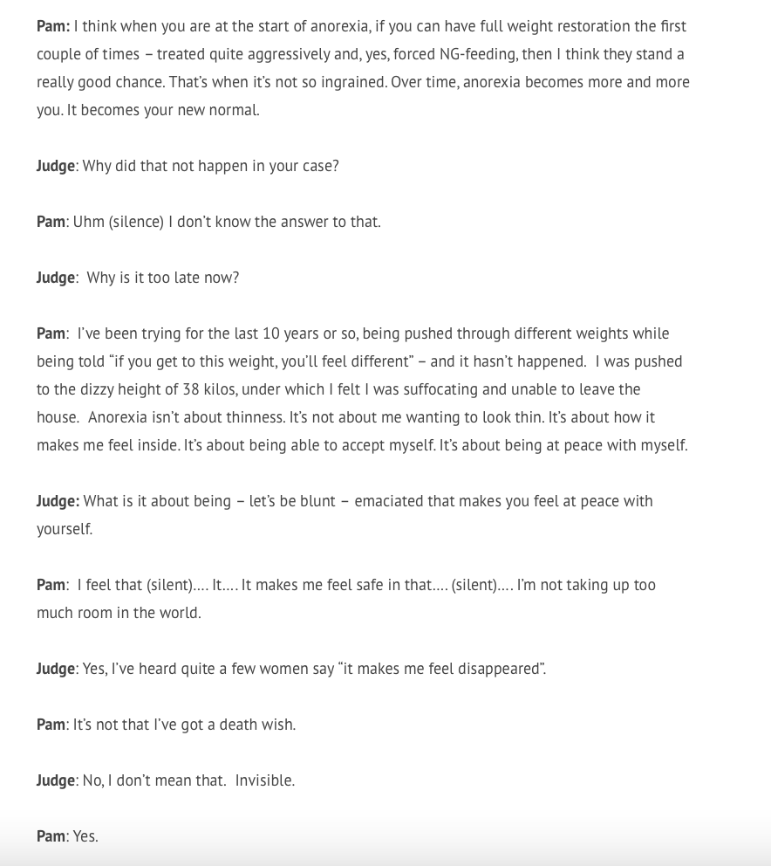

7. References to published works
Links to other blog posts from the Open Justice Court of Protection Project are encouraged. So are links to published judgments. Please be sparing in referencing other publications – these are blog posts, not academic articles, and they’re based on your experience as an observer in court, not on academic theory. Nevertheless, there may well be occasions when it is appropriate to add references – for example to a section of the Mental Capacity Act 2005, or a published judgment. You may also want to reference professional guidelines or codes of practice. It may also be appropriate to reference a scholarly analysis that you consider relevant to your views and opinions about a particular decision. We prefer you to reference publications that are not behind paywalls where possible. References should be provided by way of hyperlinks in the text (not as footnotes or endnotes).
8. Footnotes
Please keep them to an absolute minimum. If you’re tempted to use one, please consider if it can be incorporated into the text instead.
9. Hearing details
As a general rule, all blog posts should include the COP case number, the name of the judge, and the date of the hearing. These are all supplied in the listing so you may want to screenshot the listing to ensure you have this information to hand. It’s good practice to include the names of counsel as well, so please try to obtain this information when you watch the hearing. If there’s an earlier blog post about the case you plan to watch, look to see who the barristers are: they are often (not always) in same barristers in subsequent hearings in the same case.
10. Short biography
We like to include short biographical notes about the author(s) at the end of each blog post. Please have a look at previously published blog posts to see the sorts of things people write. It’s nice to include a way people can tag you on social media (e.g. X handle, LinkedIn name etc)

Open Justice Court of Protection Project Core Team Last Updated: 3.8.24

